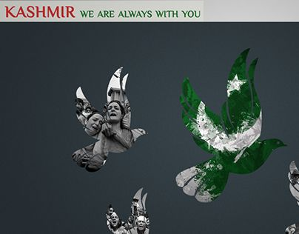
ISLAMABAD MODEL COLLEGE FOR GIRLS(POST GRADUATE) F-7/4,ISLAMABAD

Sr. No | DATES WITH DAYS | PROGRAMMES (10am-12pm)
 |  | First Half | Second Half
1- | 28th January, 2021  Thursday | - Screening of Documentary on Kashmir  - Photo Exhibition | - Popular Kashmiri Songs  - Poster Competition  Topic: Solidarity with Kashmir
2- | 29th January, 2021  Friday | - Quiz Competition | - Essay-Writing Competition (English)  Topics  i) Kashmir: The Saga of Faith and Sacrifice  ii) The Violation of Human Rights in Kashmir  iii) Better to Die Fighting for Freedom than to  Live in Slavery  iv) Kashmir and Regional Peace  - Essay-Writing Competition (Urdu)  Topics  ٭ ٭ کشمیر لہو کی تصویر  ٭ یاران جہاں کہتے ہیں کشمیر ہے جنت ٭  ٭ کشمیر ترا حسن ہوا، درد کی تصویر٭
3- | 30th January, 2021  Saturday | - Mushaira Participants  - Principal, IMCG(PG)F-7/4  Prof.Sualeha Jabeen  - Retired Teaching Faculty  Ms.Farzana Gillani  Ms.Nasreen Khalid  Ms.Rashida Saleemi  - Serving Faculty, ICT Colleges  Ms.Farah Mukhtar  Ms.Arifa  Ms.Shazia Shakeel  Mr.Shahid Chaudhary  Mr. Munir Fayyaz  Ms. Shahnaz Perveen  Ms.Fazilat Hussain | - Prize Distribution Ceremony  Poster Competition  1st Prize: Muniba Naeem  2nd Prize: Zahra Ali  3rd Prize: Zain Fatima & Iqra Ishtiaq  Quiz Competition  1st Prize: Saiqa Noureen  2nd Prize: Fiza Jilani  3rd Prize: Shanza Gul  Essay Writing Competition(English)  1st Prize: Saleha Ahmad  2nd Prize: Rabail Arshad  3rd Prize: Minahil Adnan  Essay Writing Competition(Urdu)  1st Prize: Nida Khan  2nd Prize: Rabail Arshad

KASHMIR SOLIDARITY DAY PICTURE GALLERY
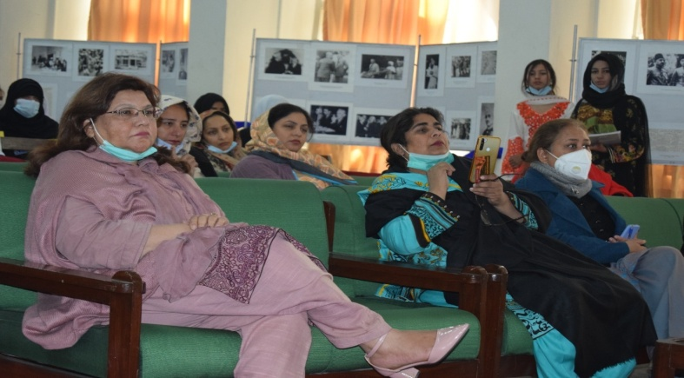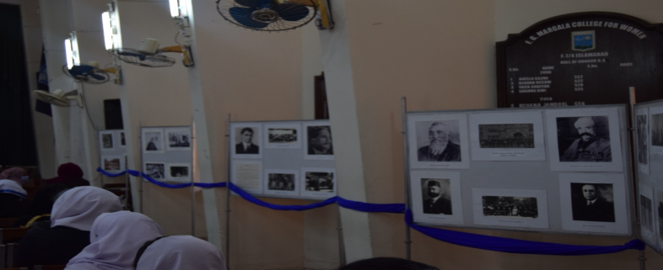
PHOTO EXHIBITION
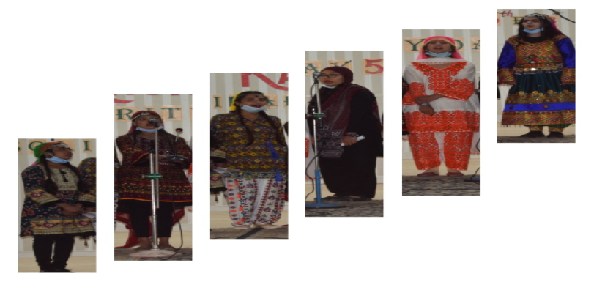
KASHMIRI SONG PARTICIPANTS
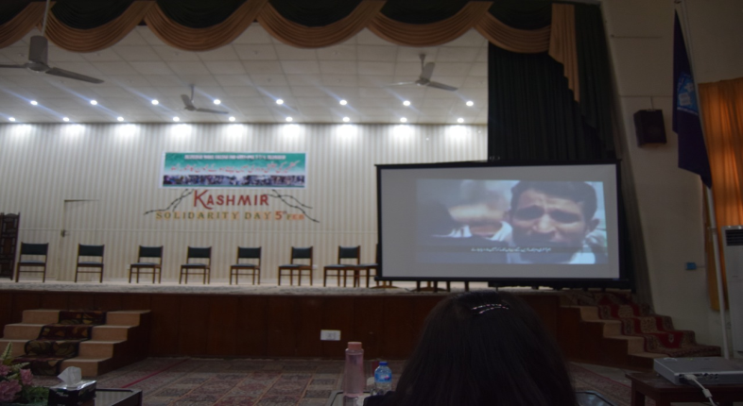
SCREENING OF DOCUMENTARY ON KASHMIR

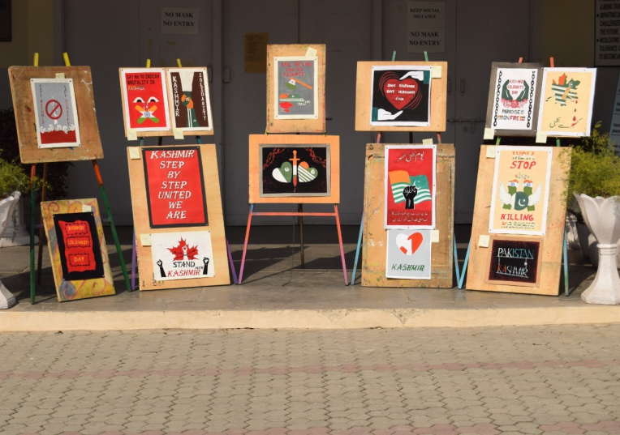
POSTER COMPETITION

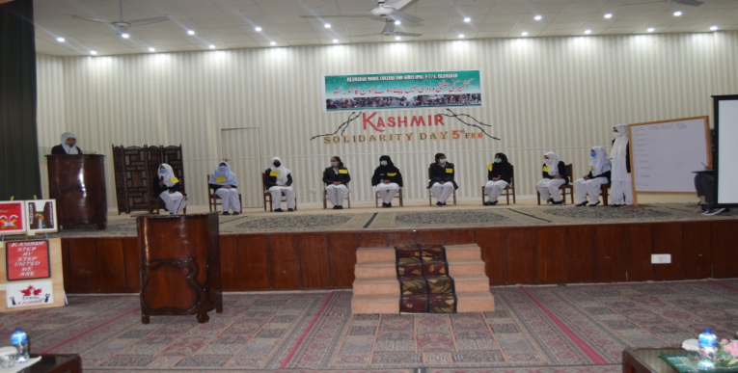
QUIZ COMPETITION
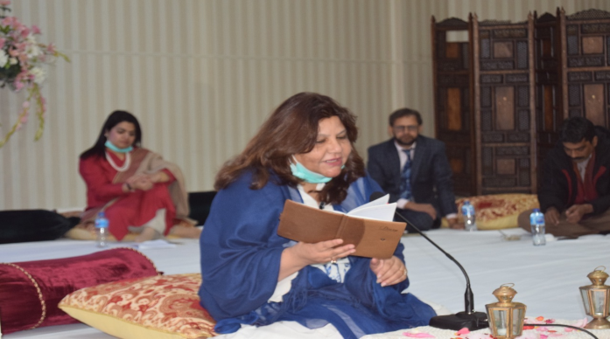
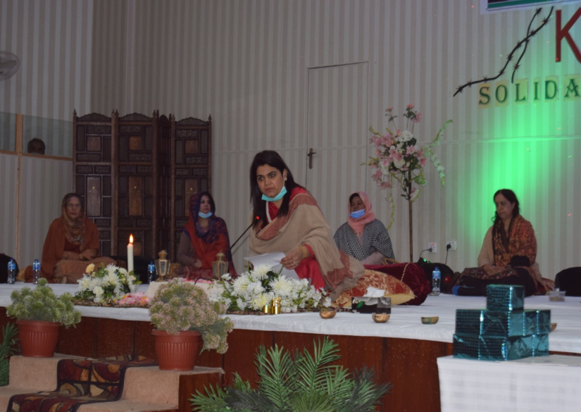
MEHFIL-E-MUSHAIRA

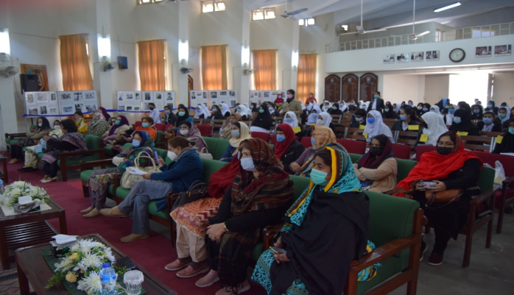

FACULTY AND STUDENTS ATTENDING THE PROGRAMME

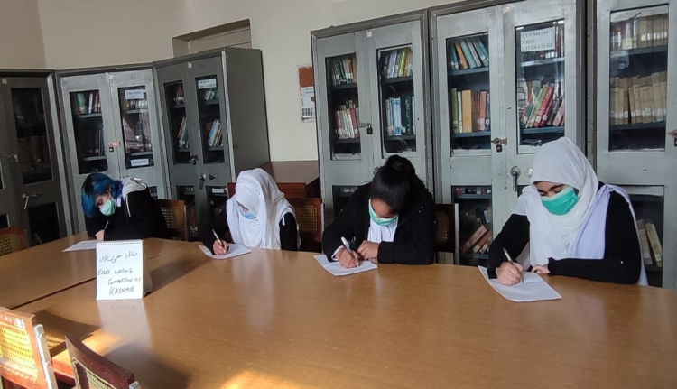
ENGLISH AND URDU ESSAY-WRITING PARTICIPANTS

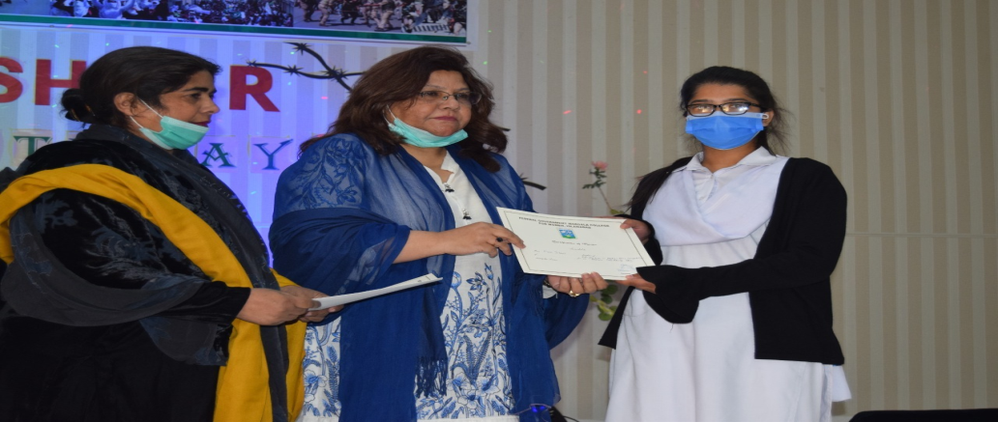
PRIZE DISTRIBUTION CEREMONY
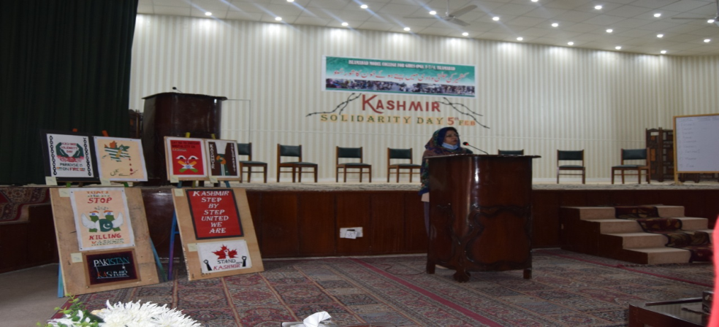

SPECIAL PRAYER FOR IOK AND MARTYRS

